**PIZZA SALES ANALYSIS**

-- Dropping the schema "pizza_sales_schema" if already exists, to get rid of error.

DROP SCHEMA IF EXISTS PIZZA_SALES_SCHEMA;

-- Creating a Schema named "pizza_sales_schema"

CREATE SCHEMA PIZZA_SALES_SCHEMA;

-- Making use of pizza_sales_schema as the default schema for the further queries.

USE PIZZA_SALES_SCHEMA;

-- Viewing the data in the pizza_sales table.

SELECT * FROM pizza_sales;

**KPI Requirements:**

1. **Total Revenue:** Sum of Total Price of all pizza orders.

SELECT SUM(total_price) AS Total_Revenue FROM pizza_sales;

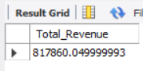

1. **Average Order Value:** The average amount spent per order, calculated by dividing total revenue by total number of orders.

SELECT (SUM(total_price) / COUNT(DISTINCT(order_id))) AS Average_Order_Value FROM pizza_sales;

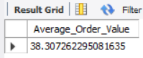

1. **Total Pizzas Sold:** Sum of the quantities of all pizzas sold.

SELECT SUM(quantity) AS Total_Pizzas_Sold FROM pizza_sales;

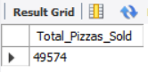

1. **Total Orders:** Total number of orders placed.

SELECT COUNT(DISTINCT(order_id)) AS Total_Orders FROM pizza_sales;

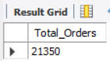

1. **Average Pizzas Per Order:** Average number of pizzas sold per order, calculated by dividing total_pizzas_sold by total number of orders.

SELECT (SUM(quantity) / COUNT(DISTINCT(order_id))) AS Average_Pizzas_Per_Order FROM pizza_sales;

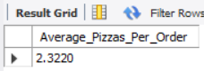

**CHART Requirements:**

-- 1) Daily Trend for Total Orders

SELECT

DATE_FORMAT(order_date, '%a') AS order_day,

COUNT(DISTINCT order_id) AS num_of_orders

FROM pizza_sales

GROUP BY 1;

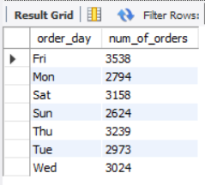

-- 2) Monthly Trends for Total Orders

SELECT

DATE_FORMAT(order_date, '%b') AS Month_abbr,

COUNT(DISTINCT order_id) AS total_orders

FROM pizza_sales

GROUP BY 1

ORDER BY 2 DESC;

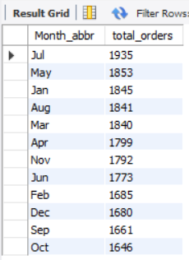

-- 3) Percentage of Sales by Pizza Category

SELECT

Pizza_Category,

ROUND(SUM(total_price), 2) AS Total_Sales,

ROUND((SUM(total_price) / (SELECT SUM(total_price) FROM pizza_sales)) * 100, 2) AS Sales_Percentage

FROM

pizza_sales

GROUP BY

Pizza_Category;

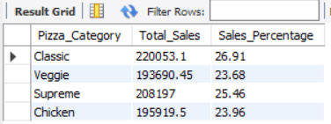

-- 4) Percentage of Sales by Pizza Size

SELECT

pizza_size,

ROUND(SUM(total_price), 2) AS Total_Sales,

ROUND((SUM(total_price) / (SELECT SUM(total_price) FROM pizza_sales)) * 100, 2) AS Sales_Percentage

FROM pizza_sales

GROUP BY 1;

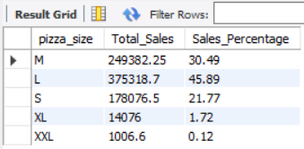

-- 5) Total Pizzas sold by Pizza Category

SELECT

pizza_category,

COUNT(pizza_id) AS total_pizzas_sold

FROM pizza_sales

GROUP BY 1;

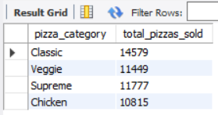

-- 6) Top 5 Best Sellers based on revenue

SELECT

pizza_name,

SUM(total_price) AS total_sales

FROM pizza_sales

GROUP BY 1

ORDER BY 2 DESC

LIMIT 5;

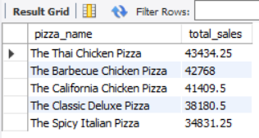

-- 7) Bottom 5 Worst Sellers based on revenue

SELECT

pizza_name,

SUM(total_price) AS total_sales

FROM pizza_sales

GROUP BY 1

ORDER BY 2

LIMIT 5;

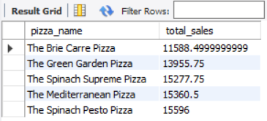

-- 8) Top 5 Best Sellers based on Total Quantity

SELECT

pizza_name,

SUM(quantity) AS total_quantity

FROM pizza_sales

GROUP BY 1

ORDER BY 2 DESC

LIMIT 5;

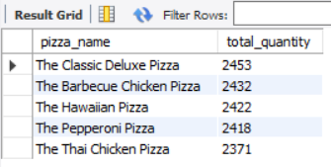

-- 9) Bottom 5 Worst Sellers based on Total Quantity

SELECT

pizza_name,

SUM(quantity) AS total_quantity

FROM pizza_sales

GROUP BY 1

ORDER BY 2

LIMIT 5;

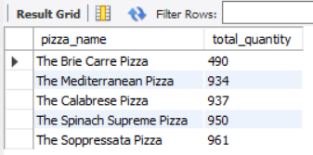

-- 10) Top 5 Best Sellers based on Total Orders

SELECT

pizza_name,

COUNT(DISTINCT order_id) AS total_orders

FROM pizza_sales

GROUP BY 1

ORDER BY 2 DESC

LIMIT 5;

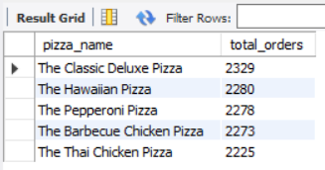

-- 11) Bottom 5 Worst Sellers based on Total Orders

SELECT

pizza_name,

COUNT(DISTINCT order_id) AS total_orders

FROM pizza_sales

GROUP BY 1

ORDER BY 2

LIMIT 5;

